Instructions on how to fill out the Web-Based IT Equipment Loan Request Form

Start by filling in out your name in the field “Requested By”, your email in the field “Email” will be filled automatically when you select your name from the dropdown. The date in which this request is needed in the field “Date needed” and the date when you will be returning the equipment on “When will you return it?”

NOTE: All fields marked with an asterisk (*) are required.

The field “Date needed” will be automatically filled with the date one week from today’s date. If your request needs to be processed by a different date click on the field and chose the desired date form the drop down calendar.

Equipment Needed

Next you need to select the equipment that you need to borrow and provide an explanation of why you need it on “Reason/Description for the selected equipment”.

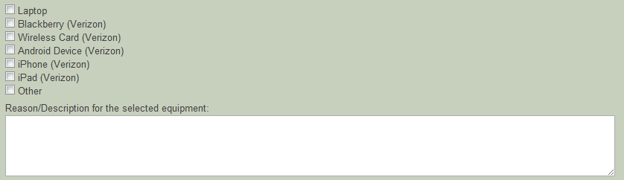

Usage Requirements

Then select where you will be using this equipment, use the “Additional description” box to provide any comments about the usage requirements.

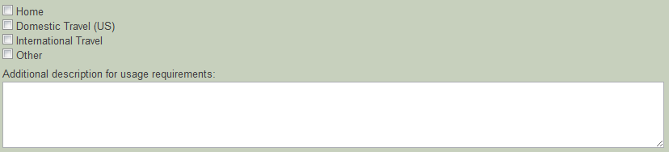
Additional Notes

We’ve also provided a place where you can type a special requirement that isn’t covered in the form or any additional notes/comments for the Helpdesk.

Signature

First select your Department/Account to be charged and then type in your manager’s name, his/her email will be filled automatically when you select a name form the dropdown.

NOTE: This section is required. If the form is not signed it will not be processed. Your manager, will receive an email with a copy of the form and he/she will have the opportunity to make changes to your request. Your request will not be processed by IT until your manager approves it.

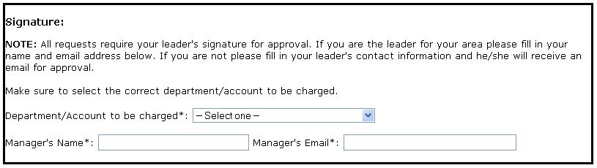

If your manager approves your request you will receive a copy of the form as a confirmation that it was approved and a copy of the completed form will be sent to the helpdesk.

- Managers will have up to 60 days to approve forms, after 60 days your form will expire and will be deleted.
- Managers can make changes to the request before approving it.
- Once your manager approves and submits your form, it cannot be modified electronically. For help with making changes to submitted request forms please contact the helpdesk.

If you have any problems with the form please contact the helpdesk.

Thank you

